SRM INSTITUTE OF SCIENCE AND TECHNOLOGY FACULTY OF ENGINEERING AND TECHNOLOGY DEPARTMENT OF CHEMISTRY

*18CYB101J-CHEMISTRY* PART-B - 3 Mark Questions Module-2

1. Give any two factors that influence crystal field splitting in octahedral complexes.

The factors which influence the splitting in octahedral complexes are

* the nature of the metal ion.
* the metal's oxidation state. A higher oxidation state leads to a larger splitting relative to the spherical field.
* the arrangement of the ligands around the metal ion.
* the coordination number of the metal (i.e. tetrahedral, octahedral...)
* the nature of the ligands surrounding the metal ion. The stronger the effect of the ligands then the greater the difference between the high and low energy *d* groups.

1. What is Pairing energy (P)? Give the relation between crystal field splitting in octahedral complexes (ΔO) and pairing energy (P).

Pairing energy, P, is the energy required to place two electrons in

the same orbital. If the crystal field splitting (Δ) is small because of weak-bonding ligands, then the pairing energy will be larger, and the complex will be high-spin. If the crystal field splitting (Δ) is large because of strong-bonding ligands, then the pairing energy will be smaller, and

the complex will be low-spin.

1. Give the splitting pattern of d-orbitals in Td complexes in the presence of ligands.

In a tetrahedral crystal field splitting, the *d*-orbitals again split into two groups, with an energy difference of Δtet. The lower energy orbitals will be *d* 2 and *d* 2 2, and the higher energy orbitals will

*z x* -*y*

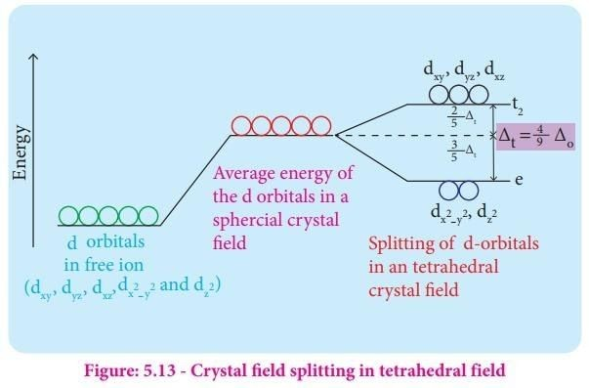be *dxy*, *dxz* and *dyz* - opposite to the octahedral case.

1. Give the formula for calculating CFSE in Td complexes.

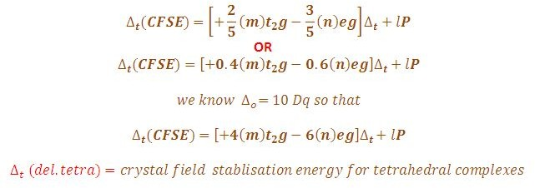

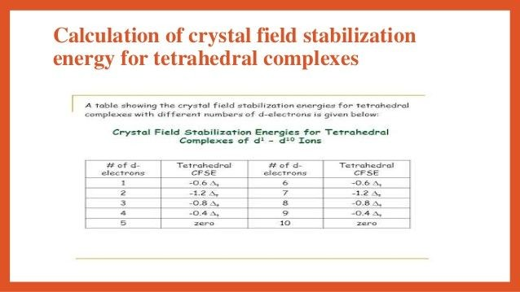

1. Why does TD geometry favours to form High spin rather low spin complexes?

In a tetrahedral complex, ΔtΔt is relatively small even with strong-field

ligands as there are fewer ligands to bond with. It is rare for the ΔtΔt of tetrahedral complexes to exceed the pairing energy. Usually, electrons will move up to higher energy orbitals rather than pairs. Because of this, *most tetrahedral complexes are high spin.*

1. What is a spectrochemical series? Mention its importance.

The spectrochemical series is a list of ligands (attachments to a metal ion) arranged in order of their field strength. The order of common ligands according to their increasing ligand field strength.

The ligands cyanide and CO are considered strong-field ligands and the halides are called weak-field ligands. Ligands such as water and ammonia are said to produce medium field effects.

1. Calculate CFSE for high spin Td complexes having d5 , d6 , d7 , and d8 configurations.



1. Calculate the magnetic moment value for the following complexes and predict whether paramagnetic or diamagnetic.
2. Low spin Oh complex with d7 and

t2g5 eg2 - paramagnetic

1. High spin Td complex with d4 configurations. eg4 t2g0 - diamagnetic
2. Classify the following as high spin or low spin complexes and calculate the magnetic moment of the complexes.
3. [CoF ]3-

6

t g4 eg2 - paramagnetic

2

1. [NiCl ]2-

4

eg2 t g2 - paramagnetic

2

1. [Fe(CN) ]3-

6

t g6 eg0 - diamagnetic

2

1. [CoCl ]2-

4

eg2 t g2 - paramagnetic

2

1. What is the electromagnetic spectrum and give its different regions?

Electromagnetic spectrum, the entire distribution of [electromagnetic](https://www.britannica.com/science/electromagnetic-radiation) [radiation](https://www.britannica.com/science/electromagnetic-radiation) according to [frequency](https://www.britannica.com/science/frequency-physics) or [wavelength](https://www.britannica.com/science/wavelength). Although all electromagnetic waves travel at the [speed of light](https://www.britannica.com/science/speed-of-light) in a vacuum, they do so at a wide range of frequencies, wavelengths, and [photon](https://www.britannica.com/science/photon) energies.

The electromagnetic [spectrum](https://www.britannica.com/science/spectrum) [comprises](https://www.merriam-webster.com/dictionary/comprises) the span of all electromagnetic radiation and consists of many subranges, commonly referred to as portions, such as visible light or ultraviolet radiation. The various portions bear different names based on differences in behaviour in the emission, transmission, and [absorption](https://www.britannica.com/science/absorption-physics) of the corresponding waves and also based on their different practical applications. There are no precise accepted boundaries between any of these [contiguous](https://www.merriam-webster.com/dictionary/contiguous) portions, so the ranges tend to overlap.

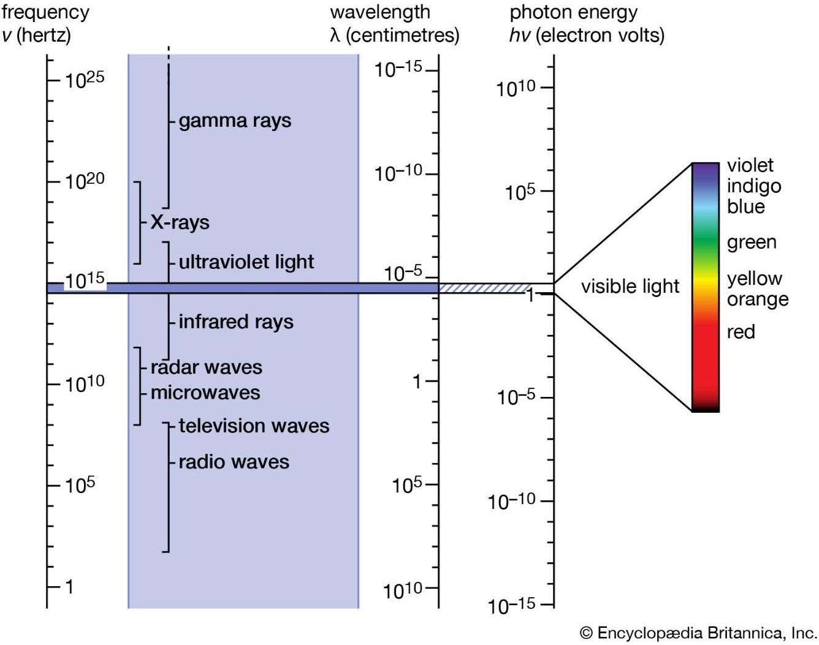

1. What is the significance of the selection rule in spectroscopy?

A selection rule describes how the probability of transitioning from one level to another cannot be zero. It has two sub-pieces: a gross selection rule and a specific selection rule. A gross selection rule illustrates characteristic requirements for atoms or molecules to display a spectrum of a given kind, such as an IR spectroscopy or a microwave spectroscopy. Once the atom or molecules follow the gross selection rule, the specific selection rule must be applied to the atom or molecules to determine whether a certain transition in quantum number may happen or not.

Selection rules specify the possible transitions among quantum levels due to absorption or emission of electromagnetic radiation.

1. What are the criteria for a molecule to absorb in the Microwave region?

During a transition, the rotational quantum number must change by 1 unit only, i.e. Δ*J* = ±1 (angular momentum is conserved).

In other words, only transitions between neighbouring energy levels are

possible.

1. Give examples for microwave active and inactive molecules.

Gross Selection Rule: molecules with permanent dipoles are microwave active (the molecule must be polar), e.g., heteronuclear diatomic - HCl, CO, NO, etc.

Homonuclear diatomics are microwave inactive (e.g., O2, N2, etc.)

In other words, a dipole must be present in the molecule for you to get a rotational spectrum.

1. Write a short note on the selection rule for Rotational (microwave) spectroscopy?

A photon contains one unit of angular momentum, so when it interacts with a molecule it can only impart one unit of angular momentum to the molecule. This leads to the selection rule that a transition can only occur between rotational energy levels that are only one quantum rotation level (J) away from another.

ΔJ = ±1

The transition moment integral and the selection rule for rotational transitions tell if a transition from one rotational state to another is allowed.

1. What are allowed and forbidden transitions in spectroscopy?

Selection rules, accordingly, may specify “allowed transitions,” those that have a high probability of occurring, or “forbidden transitions,” those that have minimal or no probability of occurring.

1. Define Hooke’s law and give its significance in IR spectroscopy.

Hooke's Law states:

* + The vibrational frequency is proportional to the strength of the spring; the stronger the spring, the higher the frequency.
  + the vibrational frequency is inversely proportional to the masses at the

ends of the spring; the lighter the weights, the higher the frequency.

Hooke's Law in IR spectroscopy means:

* + stronger bonds absorb at higher frequencies.
  + weaker bonds absorb at lower frequencies.
  + bonds between lighter atoms absorb at higher frequencies.
  + bonds between heavier atoms absorb at lower frequencies.

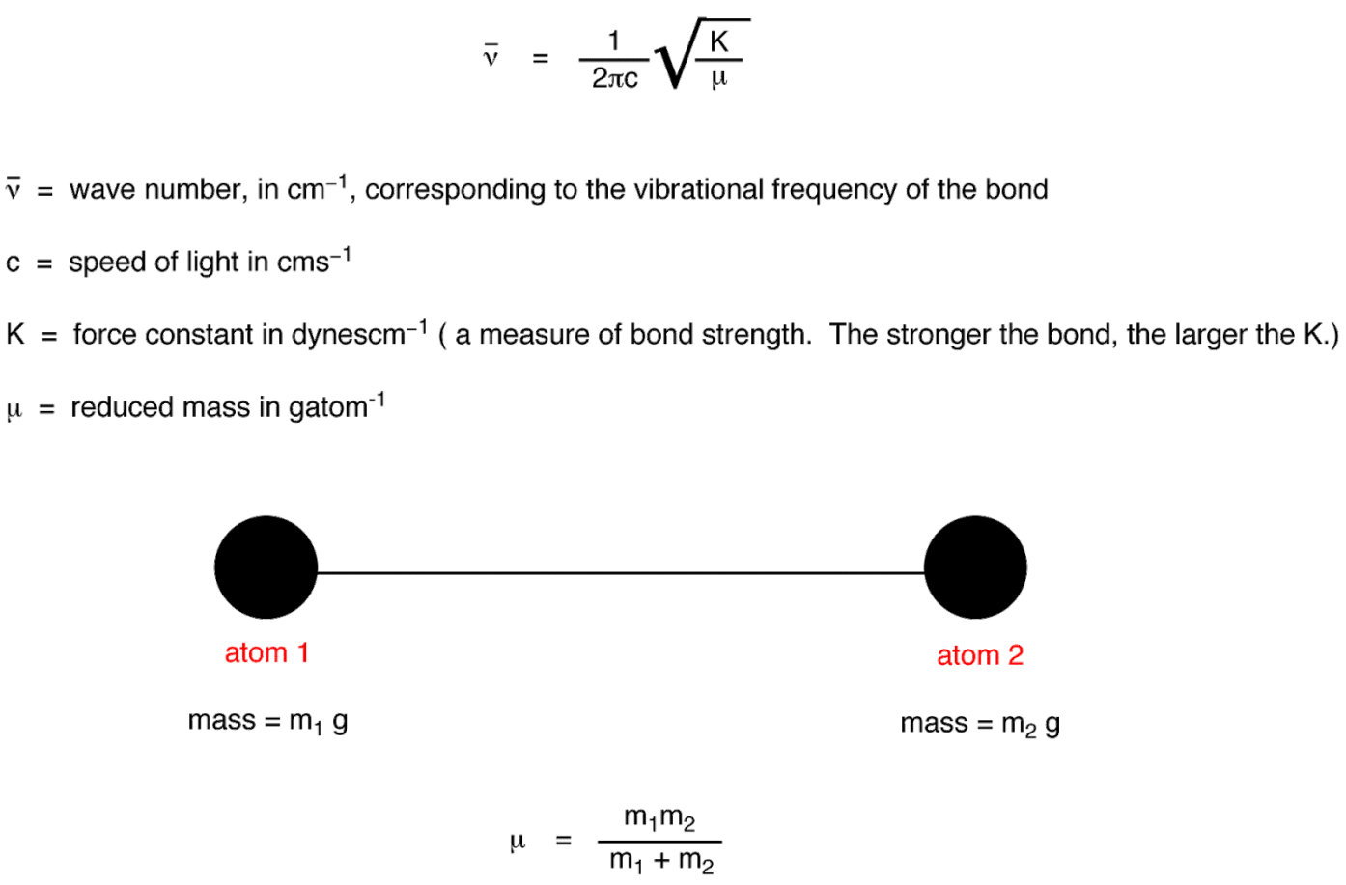

1. What are the criteria for a molecule to absorb in the IR region?

A criterion for IR absorption is a net change in dipole moment in a molecule as it vibrates or rotates. Using the molecule HBr as an example, the charge distribution between hydrogen and bromine is not evenly distributed

since bromine is more electronegative than hydrogen and has a higher electron density. HBr thus has a large dipole moment and is thus polar.

1. Give the selection rule for IR spectroscopy? Selection rules for Infrared transitions

For a particular vibration to be infrared active there must be a change in the dipole moment of the molecule during the vibration. In other words, the transition dipole moment must not be zero.

∆ν = ± 1, transition can take place between Adjacent vibrational levels, 0 to 1, 1 to 2 etc.

1. What is an IR active and Inactive molecule? Give examples.

Homonuclear diatomic molecules are inactive in the infrared spectrum. They do not have a dipole moment to start with and during the vibration also the dipole moment is zero. e.g.: H2, O2, N2 etc.

Heteronuclear diatomic molecules such as CO, NO are active in IR.

Symmetrical polyatomic molecules such as CO2, the symmetric stretching vibration is infrared inactive whereas the asymmetric stretching vibration is IR active.

1. What is the spin selection rule in electronic spectra?

The wave function of a single electron is the product of a space-dependent wave function and a [spin](https://en.wikipedia.org/wiki/Spin_(physics)) wave function. Spin is directional and can be said to have odd [parity](https://en.wikipedia.org/wiki/Parity_(physics)). It follows that transitions in which the spin "direction" changes are forbidden. In formal terms, only states with the same total [spin quantum number](https://en.wikipedia.org/wiki/Spin_quantum_number) are "spin-allowed".

1. Write a note on Laporte or orbital selection rule.

The [Laporte rule](https://en.wikipedia.org/wiki/Laporte_rule) is a selection rule formally stated as follows:

In a [centrosymmetric](https://en.wikipedia.org/wiki/Centrosymmetric) environment, transitions between like [atomic](https://en.wikipedia.org/wiki/Atomic_orbitals) [orbitals](https://en.wikipedia.org/wiki/Atomic_orbitals) such as *s*-*s*, *p*-*p*, *d*-*d*, or *f*-*f,* transitions are forbidden. The Laporte rule

(law) applies to [electric dipole transitions](https://en.wikipedia.org/wiki/Electric_dipole_transition), so the operator has *u* symmetry (meaning *ungerade*, odd). *p* orbitals also have *u* symmetry, so the symmetry of the transition moment function is given by the [triple product](https://en.wikipedia.org/wiki/Direct_product_of_groups) *u*×*u*×*u*, which has *u* symmetry. The transitions are therefore forbidden. Likewise, *d* orbitals have *g* symmetry (meaning *gerade*, even), so the triple product *g*×*u*×*g* also has *u* symmetry and the transition is forbidden.

1. Explain the criteria for a molecule to absorb radio frequency waves in the NMR region.

The NMR spectroscopy depends upon the fact that most isotopes of the

elements possess gyromagnetic properties, which means that they behave like tiny spinning bar magnets. When a sample containing nuclei exhibiting this immutable gyro magnetism is placed in an appropriate DC magnetic field and is simultaneously irradiated by a weaker rotating radiofrequency magnetic field, the nuclei can be compelled to reveal their presence, identify themselves and describe the nature of their surroundings.

1. What is NMR active and inactive nuclei? Give examples.

The spin of atomic nuclei can be predicted based on the knowing the number of protons and neutrons in the nucleus:

* Even/Even. Nuclei that contain an even number of protons *and* an even number of neutrons have I=0 and are NMR silent.
* Examples: C12, O16 and S32. *All other nuclei are NMR active*:
* Odd/Odd. Nuclei that contain an odd number of protons *and* an odd number of neutrons have I that are positive integers. Examples:

H2 (I=1), N14 (I=1) and B10 (I=3).

* Odd/Even & Even/Odd. All other nuclei (odd/even and even/odd) have spins that are half integral.

Examples: H1 (I=1/2), B11 (I=3/2), C13 (I=1/2), O17 (I=5/2), F19 (I=1/2) and P31 (I=1/2).

1. What are the two scales used to calculate chemical shift values?

There are two chemical-shift scales, viz., the δ-scale and the ζ – scale is used in recording NMR signals. They are related by the expression

δ + ζ = 10 i.e., ζ = 10 - δ

Chemical shift [*δ*](https://en.wikipedia.org/wiki/Delta_(letter))is usually expressed in [parts per million](https://en.wikipedia.org/wiki/Parts_per_million) (ppm) by [frequency](https://en.wikipedia.org/wiki/Frequency), because it is calculated from

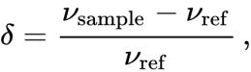

where *ν*sample is the absolute resonance frequency of the sample and *ν* is the absolute resonance frequency of a standard reference compound, measured in the same applied magnetic field *B*0. Since the numerator is usually expressed in [hertz](https://en.wikipedia.org/wiki/Hertz), and the denominator in [megahertz](https://en.wikipedia.org/wiki/Megahertz), *δ* is expressed in ppm.

ref

1. Give any two references (or) standards used in NMR spectroscopy.

The detected frequencies (in Hz) for 1H, 13C, and 29Si nuclei are usually referenced against TMS ([tetramethylsilane](https://en.wikipedia.org/wiki/Tetramethylsilane)), TSP ([Trimethylsilylpropanoic acid](https://en.wikipedia.org/wiki/Trimethylsilylpropanoic_acid)), or [DSS](https://en.wikipedia.org/wiki/DSS_(NMR_Standard)), which by the definition above have a chemical shift of zero if chosen as the reference.

1. What is the shielding and deshielding effect in NMR spectra? The Nucleus feels a weaker magnetic field.

Shielding is a barrier made of inner-shell electrons and it decreases the nucleus’ pull on the outer electrons. Shielding is defined as “a nucleus whose chemical shift has been decreased due to addition of electron density, magnetic induction, or other effects.”

The Nucleus feels a stronger magnetic field.

Deshielding is the opposite of shielding. When we say that an atom is deshielded, we mean that “A nucleus whose chemical shift has been increased due to removal of electron density, magnetic induction, or other effects.”

1. What is Larmor (or) precessional frequency?

The Larmor or precessional frequency in [MRI](https://radiopaedia.org/articles/mri-2?lang=gb) refers to the rate of precession of the magnetic moment of the proton around the external magnetic field. The frequency of precession is related to the strength of the magnetic field, [B0](https://radiopaedia.org/articles/b0-1?lang=gb).

The precessional frequency of nuclei of a substance placed in a static magnetic field B0 is calculated from the Larmor Equation:

ω = γB

where ω is the Larmor frequency in MHz, γ is the [gyromagnetic ratio](https://radiopaedia.org/articles/gyromagnetic-ratio?lang=gb) in MHz/tesla and B is the strength of the static magnetic field in tesla.

1. Define the term chemical shift and give the model of NMR spectrum for ethanol molecules.

The NMR spectra is displayed as a plot of the applied radio frequency versus the absorption. The applied frequency increases from left to right, thus the left side of the plot is the low field, downfield or deshielded side and the right side of the plot is the high field, upfield or shielded side (see the figure below). The concept of shielding will be explained shortly.

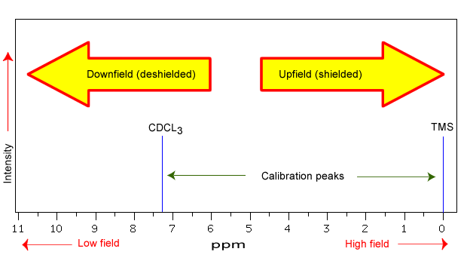

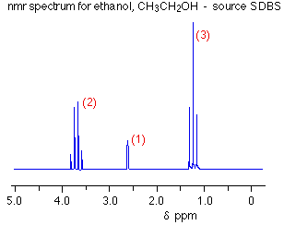

The left-hand cluster of peaks is due to the CH2 group. It is a quartet because of the 3 hydrogens on the next door CH3 group. You can ignore the effect of the -OH hydrogen. Similarly, the -OH peak in the middle of the spectrum is a singlet. It hasn't turned into a triplet because of the influence of the CH2 group.

1. How many values can the magnetic quantum number have?

The magnetic quantum number distinguishes the [orbitals](https://en.wikipedia.org/wiki/Atomic_orbital) available within a [subshell](https://en.wikipedia.org/wiki/Electron_shell), and is used to calculate the azimuthal component of the orientation of orbital in space. Electrons in a particular subshell (such as s, p, d, or f) are defined by values of *ℓ* (0, 1, 2, or 3). The value of *ml* can range from

-*ℓ* to +*ℓ*, including zero. Thus, the s, p, d, and f subshells contain 1, 3, 5, and 7

orbitals each, with values of *m* within the ranges 0, ±1, ±2, ±3 respectively. Each of these orbitals can accommodate up to two electrons (with opposite spins), forming the basis of the [periodic table](https://en.wikipedia.org/wiki/Periodic_table).

1. Write down possible values m can have for a nucleus with I=1. Draw the energy level diagram for it.

For the proton in a field of 1 T, νL = 42.576 MHz, as the proton spin orientation flips from +1/2 to −1/2. This transition is in the radiofrequency region of the electromagnetic spectrum.

